6.1 – end

6.2 – end

6.3 – 19,21

6.4 – 8 ,26

7.1 – end

Rank theorem:

A = m * n

Rank A + Dim(Nul(A)) = n

Rank A = Dim(Col(A))

Rank A = # of non-zeros on the diagonal

Dim(Col(A)) = number of pivot columns

Dim(Nul(A)) = # of free variables ⊻ number of non-pivot columns

Defs:

* rank :

The maximum number of linearly independent vectors in a **matrix** is equal to the number of non-zero rows in its row echelon **matrix**. Therefore, to find the **rank of a matrix**, we simply transform the **matrix** to its row echelon form and count the number of non-zero rows.

* basis:

The vectors that are [linearly independent](https://en.wikipedia.org/wiki/Linearly_independent) and every vector in the vector space is a [linear combination](https://en.wikipedia.org/wiki/Linear_combination) of this set.

In other words, a basis is a linearly independent [spanning set](https://en.wikipedia.org/wiki/Spanning_set).

A basis is a set of vectors that generates all elements of the vector space and the vectors in  the set are linearly independent.

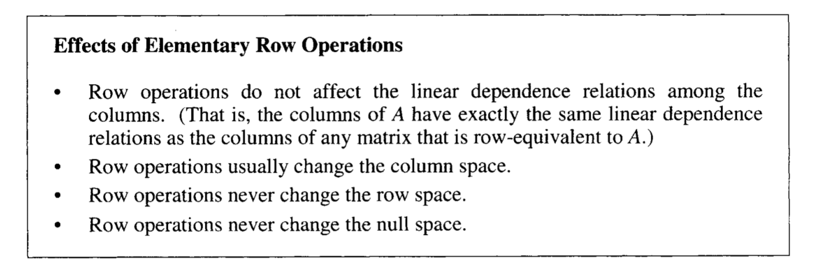

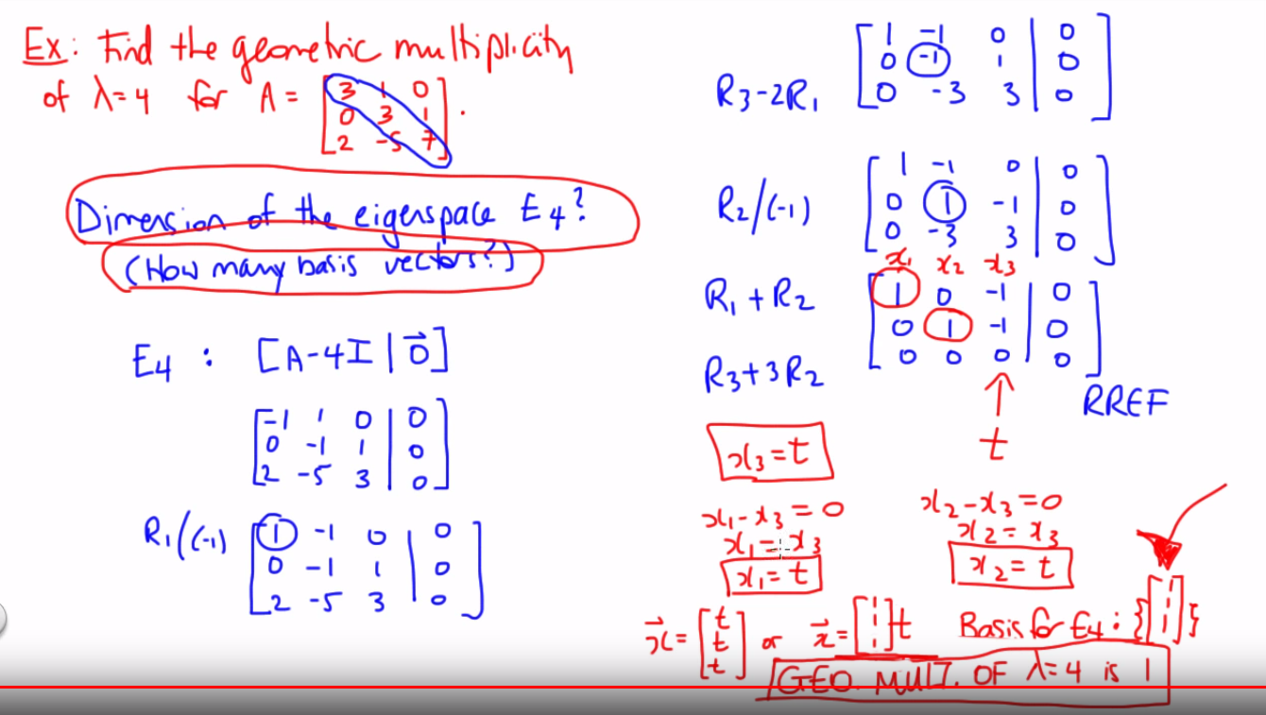

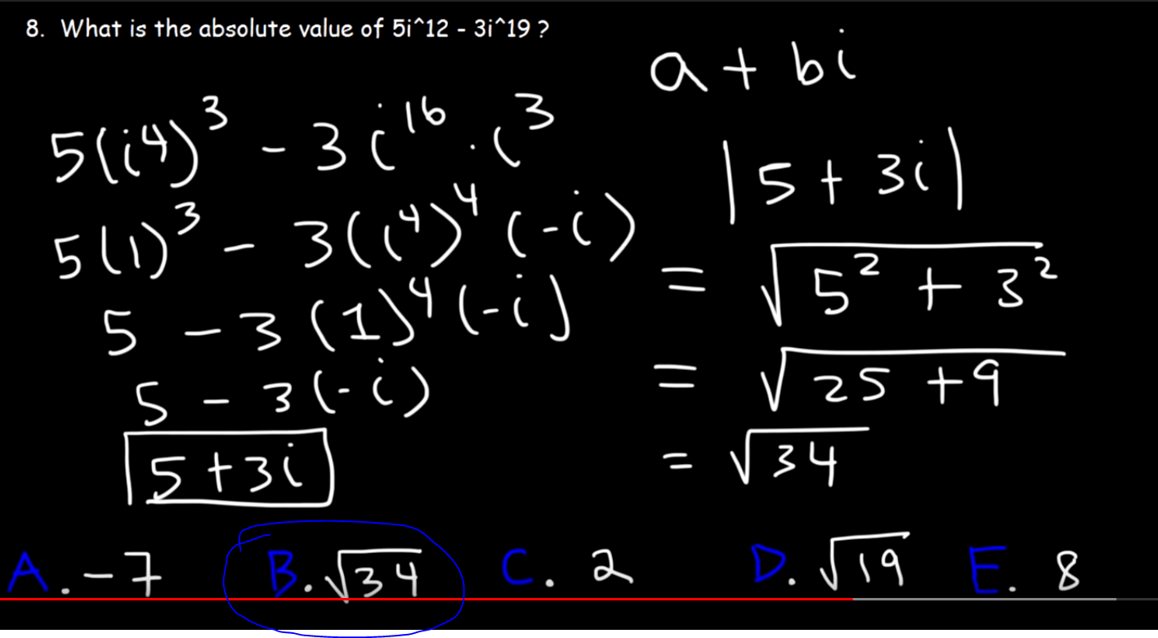

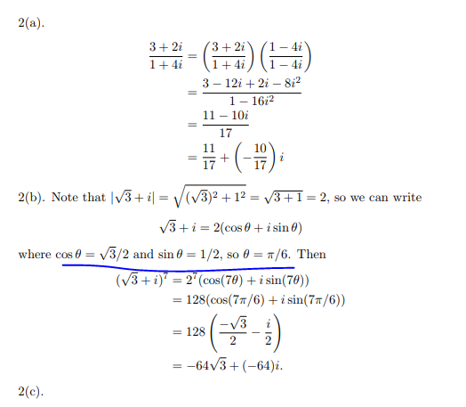

Eigen value is determinate is equal to 0

<https://math.stackexchange.com/questions/894636/verifying-eigenvalues>

linear trans – 1-1 and onto

<https://math.stackexchange.com/questions/26371/is-a-linear-tranformation-onto-or-one-to-one>

LINEAR INDEPENDENT MEANS ONLY THE FUCKIN TRIVIAL SOLUTION. Yes 0=0 is valid at bottom